BACI Process-Based Monitoring for Lower Staley Creek Floodplain Restoration and Lower Coal Creek Floodplain Restoration
Stage 0 Monitoring Protocols and Preliminary Results: 2017-2019

Willamette National Forest
Middle Fork Ranger District

Prepared by Dylan Keel and Olivia Guthrie

Contents
Introduction: 3
Ecosystems in West-Cascades Streams 3
Nutrient Monitoring on the Middle Fork Willamette 5
Dissolved Nitrogen Water Sampling Protocol 5
Macroinvertebrate Stable Isotope Collection Protocol 10
Coarse Particulate Organic Matter (CPOM) Monitoring 14
Stream Temperature Monitoring 16
17
Flow Path Heterogeneity and Retention Rates Monitoring 17
Bull Trout Occupancy and Habitat Usage Monitoring 19
Recommendations: 22
Citations/Suggested Reading: 24

Figure 1. Adapted from Baxter et al. (2005). A generalized diagram showing reciprocal flows of invertebrate prey and inputs of plant material (dark arrows) that have direct and indirect effects in stream and riparian food webs. 4
Figure 2. Adapted from a National Park Service Report, Marine Derived Nutrient distribution flow chart 4
Figure 3. Stage height of reference stream (Steamboat Creek) throughout the experiment 7
Figure 4. biweekly nitrate/nitrite (NO3/NO2) samples above and below LSFR site and futre LCFR 8
Figure 5. biweekly Total Organic Nitrogen (TON) samples above and below LSFR and future LCFR 8
Figure 6. biweekly total dissolved nitrogen (TDN) samples above and below LSFR site and future LCFR 9
Figure 7. biweekly ammonia (NH4) samples aboce and velow LSFR site and future LCFR 9
Figure 9. Distribution of d13C/d15N ratios by species of stonefly and location. Ratios sort better by location than they do by species. There was no species effect detected. Delta isotope values in PPT. 12
Figure 10. d15N of Perlid stonefly tissues over time after addition of Chinook salmon carcasses. Detrended time series generalized liniear model shows strong evidence for increased retention of 15N in LSFR reach. Error shading = 95% confidence, delta iso value=PPT 12
Figure 11. d13C of perlid stonefly tissues over time. Strong evidence for no time-series trend, and difference betwen the upper and lower Staley Creek reaches. Error shading = 95% confidence. Delta isotope values in PPT. 13
Figure 14. Proportions of leaves retained at base flow, and a heightened winter flow. N = 5000 per release per reach. No error estimated 15
Figure 21. Detection date, and PIT tag ID codes on three antennae. STA is located at the bridge where the 2134 road crosses the Middle Fork Willamette, STA 2 is located at the downstream end of the LSFR project area, and STA3 is located upstream of LSFR. 20
Figure 22. Upper Middle Fork Willamette River, July/August 2018 eDNA detections for Bull trout. 21

Introduction:
In addition to other physical and biological objectives, restoration goals for the Lower Staley and Coal Creek Floodplain Restoration projects include: increasing the quantity and quality of spawning and foraging habitat for bull trout and spring chinook salmon, increasing complex habitat by 200%, increase water table, flood storage and residency times, promote diverse community assemblages, and increased reach-level primary productivity. We believe that monitoring these complex habitat characteristics and processes require complementary procedures to traditional patch/transect and aerial imaging monitoring. Furthermore, the level of disturbance required to restore reach-scale hydrologic processes in a degraded unconfined valley is significant, and in-depth evaluations of the impacts on food webs and ecosystem function are warranted. The goals of this monitoring effort are to consiliently measure parameters that impact the overall primary productivity and ecosystem function of the altered systems. Physical changes to habitat can be hard to relate to biological function, and while increased complexity is assumed to correlate with increased productivity, measuring only habitat parameters may lack the definition to answer some questions. This document intends to provide an overview of how these ecosystems function, which parameters are valuable and practical to measure, and evaluate some methods used for monitoring these projects.

Ecosystems in West-Cascades Streams
Cascadian streams represent some of the most oligotrophic, lotic systems and are epitomized by their reputation for being some of the clearest and cleanest in North America. Oligotrophic streams are characterized by their low available nutrient load, and seasonally variable windows of productivity, usually corresponding with leaf fall, increased sediment from high flows, or runs of anadromous fishes. Figure 1 shows the two dominant forms of primary producers that influence these systems. The first and most important is allocthonus inputs of senescing leaves which when deposited in the stream channel become detritus. Cascadian stream macroinvertebrate communities are often dominated by “shredders” or insects that exploit this seasonally available food source and account for much of the invertebrate biomass in the predominantly detrital food web. The other major form of primary productivity in these ecosystems is autocthonus algal growth which is limited by the availability of nutrients in the water column or sediments. Cascadian streams are unique in that they are limited in their in-stream primary productivity by nitrogen (rather than phosphorous) which does not naturally occur in sediments, but rather must be fixed from the atmosphere, or recycled from other decaying organisms. It is likely that historically abundant anadromous salmonids and petromyzontids accounted for a large proportion of these streams annual nitrogen budget.
Lamberti et al. (1989) provides a useful overview: “Retention of dissolved and particulate matter is of critical importance to the operation of stream ecosystems. Retention largely determines the availability of food resources to aquatic organisms. Long-term retention of detritus delivered from riparian zones, with its subsequent microbial colonization and consumption by detritivores, is critical to energy transfer in most streams. Retention of dissolved nutrients permits levels of primary production and microbial growth necessary to support grazing invertebrates. Higher consumers such as fish that rely on invertebrates for food are thus de-pendent on retention processes to supply food resources for their invertebrate prey.”

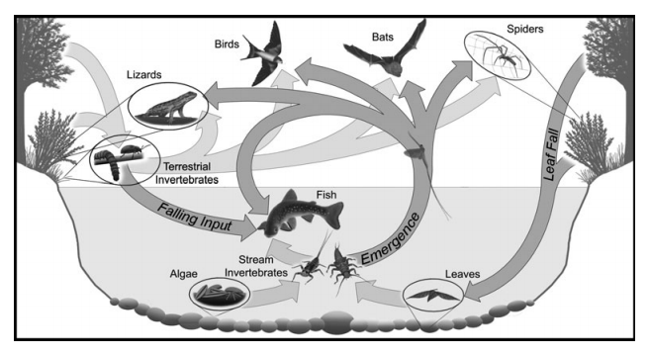
Figure 1. Adapted from Baxter et al. (2005). A generalized diagram showing reciprocal flows of invertebrate prey and inputs of plant material (dark arrows) that have direct and indirect effects in stream and riparian food webs.
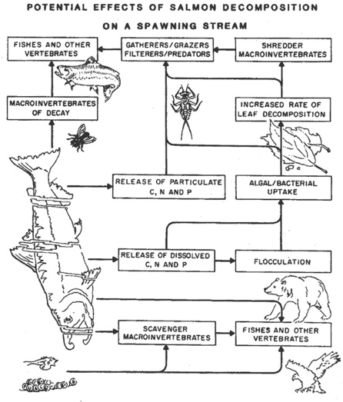
Figure 2. Adapted from a National Park Service Report, Marine Derived Nutrient distribution flow chart

Nutrient Monitoring on the Middle Fork Willamette
The tributaries of the Western-Cascadian Rivers make up the some of the most oligotrophic streams in North America. Unlike other streams where phosphorous limits productivity, nitrogen (in the easily up-taken form of nitrate (NO₃)) limits the growth of microbes that make up the base of the food web. Careful collection, and laboratory analysis are required to accurately measure the changes in in NO₃ found in these streams. Additional data collected on availability of dissolved ammonia (NH₄), total nitrogen, and total organic nitrogen from these samples will help with our interpretation of nutrient availability’s impact on the ecosystem. Alterations to hydrology through restoration may alter these dynamics, and in the case of Stage 0 restoration may alter them significantly. We chose to monitor long term nitrate trends as well as medium duration nitrogen concentrations in stream water following carcass additions to project and reference reaches.
Changes in stream morphology may alter nutrient dynamics, and primary productivity as a result. Distinct, stable isotopic signatures are diagnostic of marine sources of nitrogen, as found in salmon carcasses, and can be observed in the tissues of organisms that uptake those nutrients. Collection of macroinvertebrates, before and after carcass additions that mimic native fish runs, may illuminate the impact of changes in stream morphology on the residence time of these traceable nutrients that can greatly influence instream primary productivity.
To monitor the flow of nutrients through restored and unrestored stream reaches of the Upper Middle Fork Willamette River we elected to monitor dissolved nitrogen in stream water, and the changing proportions of ₁₅N and ₁₃C in macroinvertebrates, using the following protocols.

Dissolved Nitrogen Water Sampling Protocol
Duration: Nitrate/nitrite is sampled every other week year round. Nitrate/nitrite, total dissolved nitrogen, ammonia, and total dissolved organic nitrogen are sampled weekly, the week prior to, and six weeks following a carcass addition on Coal and Staley Creeks, and then every other week for eight additional weeks.
Supplies

- Nalgene Vacuum hand pump
- GF/C Filter Paper
- Ultra-Ware Glass Filter
- Filter flask with vacuum arm
- Adapter tubing
- Forceps
- Acid washed sample bottles
- Distilled water
- Cooler
- Ice
- Carrying Cas

At the vehicle:
- Assemble the filtering apparatus with filter paper in place.
- Filter approximately 150 ml of distilled water, adding pressure from the hand pump as needed, and making sure to pour around the whole rim of the glass funnel piece of the filter.
- Disconnect the flask from the filter and pour the filtrate on the ground, ensuring to rotate the flask to cover the entire interior.
- Repeat steps 1-3 four times, keeping the same piece of filter paper in place.
- Reattach the flask to the filter and return to the carrying case.
At the collection site:
- Set up workstation with flat surface for pouring and handling filter, flask, and sample bottles.
- Check that filter and flask are well attached.
- Fill funnel by dipping apparatus in the stream water, facing upstream, and begin filtering.
- Detach filter from flask and rinse interior of flask as done with the distilled water earlier. Only one rinse is required.
- Refill the funnel and continue to filter stream water until 300ml have been filtered.
- Return to the streamside workstation and rinse the acid-washed sample bottle with 50ml of stream water 4 times, by shaking the bottle well while the lid is secured, and pouring out the rinse well away from the filtrate that remains in the flask.
- Fill the sample bottle no more than 90% full with the filtered water that remains in the flask, and secure the lid.
- As quickly as possible, transfer the labeled sample bottle to the cooler with ice, and freeze the sample when field sampling is complete.
Note: Inclement weather conditions, contaminants from clothing or equipment, or turbid water from rain or runoff can impact the quality of the sample collected. Sample collections should be planned so work is done upstream, and in the best conditions that fall within the sampling period.
Analysis:
All nitrogen analyses were run by the Oregon State University Cooperative Chemical Analytical Laboratory (CCAL) with a Technicon Auto-Analyzer II.
Results:
Helton et al. (2001) found that wetlands, functioning hyporheic zones, and connected floodplains, may have caused their nitrogen cycling models to perform poorly, because wetlands can behave as nitrogen sinks. These areas can retain and release nitrogen more slowly, and fix and denitrify at different rates than degraded or engineered channels. Therefore we expected a different distribution of nitrogen species by type and concentration temporally after carcass placements in Stage 0 and degraded reaches.
Additionally, Cluer and Thorne (2014) acknowledge that vast quantities of stored nutrients may become available to a channel that is reconnected with its floodplain, and that nutrient cycling is heavily influenced by stream velocity. Just as a slower, anastomosed reach can be depositional regarding sediments, so too does the increased wetted area relative to the flow and degree to which it is hydrologically connected to the floodplain impact the deposition of organic nitrogen, and the potential release of bioavailable inorganic nitrogen (Nitrate NO3).
Our first year of nitrogen monitoring supported our hypothesis, that the Stage 0 reach retained NO₃. While the dissolved nitrogen exports of all stream reaches appeared highly correlated with date and stream (see Figures 4, 5, 6, and 7), and dates of higher concentrations of dissolved nitrogen correlated with reference stream stage (see Figure 3), the obvious outlier is the STA1 reach. Despite flows on all other reaches that are exhibiting peak NO₃ export during the flow events of October 29th and December 21st of the monitoring period, the restoration reach shows no detectable increase in dissolved NO₃.
- Observing an NO3 peak in all reference reaches but not in STA1, the LSFR reach, may show that even when dissolved NO3 jumps by an order of magnitude, the new channel is still able to absorb the signal. These findings may have implications for nutrient management in degraded oligotrophic systems like these, as well as eutrophic agricultural influenced systems.

We detected no clear signal of increased dissolved nitrogen export in streams treated by carcass additions, suggesting that the treated reaches, restored and unrestored, continued to be nitrogen limited throughout the experiment.

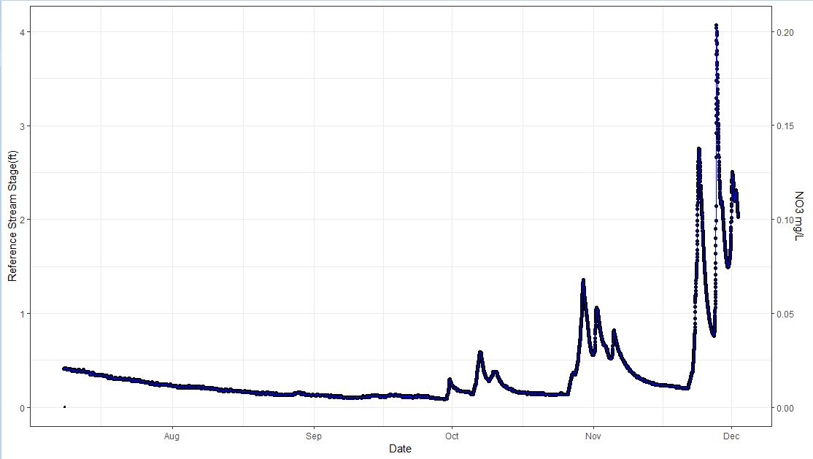
Figure 3. Stage height of reference stream (Steamboat Creek) throughout the experiment
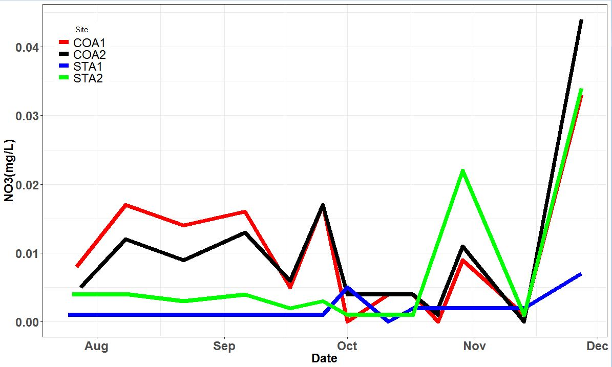
Figure 4. biweekly nitrate/nitrite (NO3/NO2) samples above and below LSFR site and future LCFR
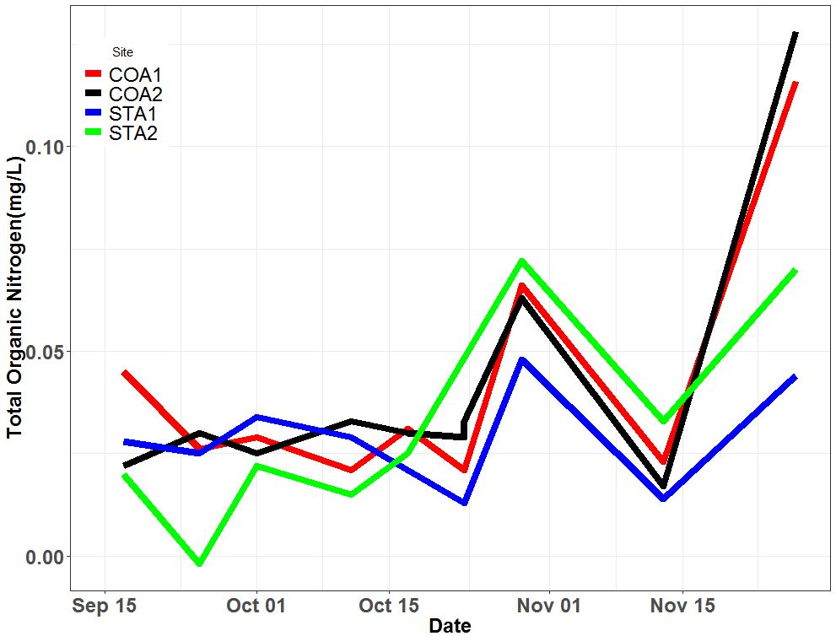
Figure 5. biweekly Total Organic Nitrogen (TON) samples above and below LSFR and future LCFR

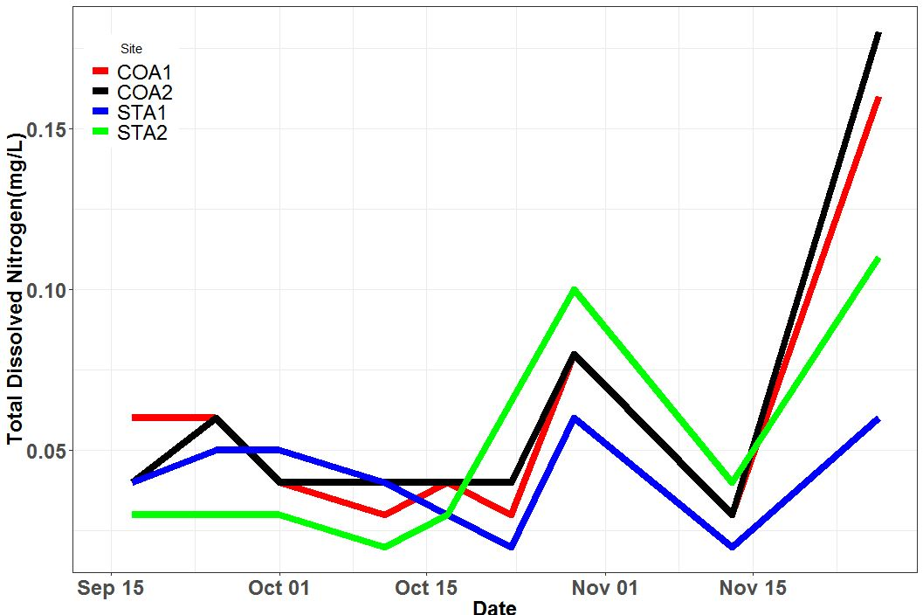
Figure 6. biweekly total dissolved nitrogen (TDN) samples above and below LSFR site and future LCFR

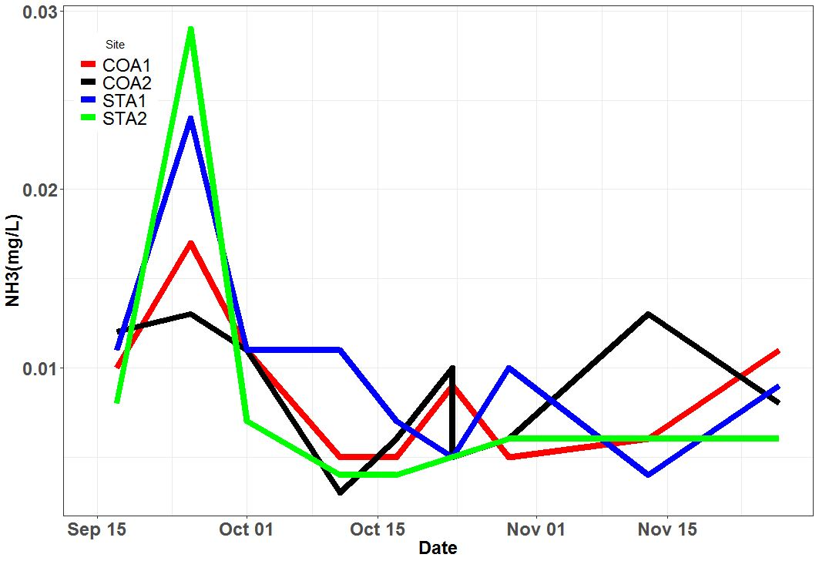
Figure 7. biweekly ammonia (NH4) samples above and below LSFR site and future LCFR

Macroinvertebrate Stable Isotope Collection Protocol

Duration:

Two weeks prior to addition of salmon carcasses to Coal and Staley Creeks, baseline macroinvertebrate samples will be collected downstream and upstream of the project reaches. Samples of macroinvertebrates will be collected weekly for 10 weeks following carcass additions. After the 10 week period, sampling with be reduced to every other week.
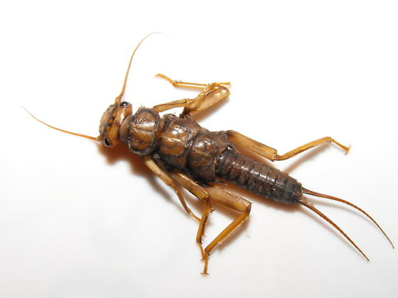
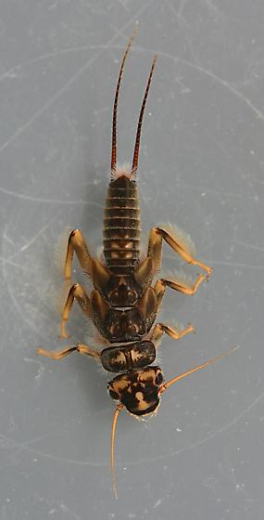
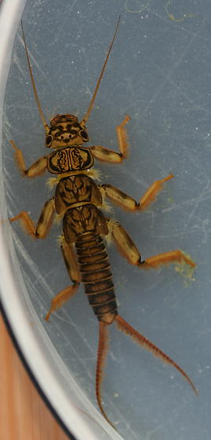
Invertebrates: Three species of Perlid stonefly are the target species. These include Calineuria californica, Hesperoperla pacifica, and Doroneuria sp.
Figure 8. Target macroinvertebrate taxa for stable isotope sampling
Calineuria californica
Hesperoperla pacifica
Doroneuria sp.

These stonefly nymphs are easily identifiable by their yellowish to brown with prominent dark pattern on dorsal surface of head and thorax; dorsoventrally flattened bodies, thoracic segments wider than long, and legs thick, giving a stout-bodied robust appearance; ventral thoracic gills profusely branched; paraglossae extend beyond glossae (i.e. they have predatory looking mouth parts) (bugguide.net).

- Sample Collection – Use a kick net and/or turn stones at the bottom of project reach to find stonefly nymphs. Collect samples in labeled whirlpack bags. Add stream water to cover the nymphs and close whirlpack. Label samples and record time, date and genus (if possible) of sample. Transport to office lab in cooler. Store samples in refrigerator overnight to allow macroinvertebrates to excavate their gut before processing.
- Sample Processing: Drying - After samples have excavated their guts overnight, samples are ready to be processed. Do not allow the samples to sit in refrigerator for more than one day, as they begin to die and decay, making further identification difficult. Pour samples and water individually onto a tray. Using methanol rinsed tweezers, place each macroinvertebrate in the sample under a stream of DI water to rinse it. Place all macroinvertebrates from the sample onto tin trays labeled with site name, date, and sample species. Place samples in drying oven or dehydrator overnight or until completely desiccated. If using a drying oven, operate the over at 35-40º C. Place dried desiccated samples into vials labeled with site, date, and samples species. Samples can be broken into replicates if the sample is large enough (One or two large stonefly nymphs are an acceptable sample size). Store samples in freezer or desiccator to prevent interaction with moisture.
- Sample Processing: Homogenizing - Using a combusted mortar and pestle, grind desiccated individual/replicate samples from same site and day samples into a fine homogenous powder. It is important to do this thoroughly, being sure to fully grind the exoskeleton. Using a mini-spatula, scrape the powder back into vial for weighing and analysis at the COAS lab. If weighing in-house, place grouynd samples into pre-weighed tin boats (0.4 to 1.0 mg). Label sample vial with unique ID, including 1, 2, or 3 if it is a replicate (eg: 001.1, 001.2, 002.1…). Wipe mortar and pestle with dry towel to remove any remaining powder. Rinse mortar, pestle, and mini spatula with methanol thoroughly between samples. Store samples in freezer or desiccator.
- Sample Analysis- Samples are analyzed for d13C and d15N at the COAS Lab at Oregon State University.

Results:

We used three species of Perlid stonefly from each reach, which we collected at any size we encountered. We used all sizes to prevent changes in isotopic makeup due to diet switching, as stoneflies became larger. Using a generalized linear model (GLM), we found no statistical effect of species on isotopic composition. While we couldn’t evaluate isotopic compostion by size of the individual, we did find that d13C and d15N ratios sort well by reach, indicating that location (and the available nutrients found there) have a greater impact on the isotopic composition of the individuals than species or stream (see Figure 9).

We used a detrended, time-series GLM to evaluate d15N among reaches and found strong evidence for an increase in d15N after carcass additions below the LSFR reach (see Figure 10). We observed no statistical change in d15N in the lower Coal Creek reach suggest that the change in hydrology creates an environment more conducive for the retention of organic nutrients. These results support our hypothesis, that a connected, lower energy floodplain has more opportunity to store the available marine derived nutrients in the organisms that utilize it, than in degraded reaches.

We used a detrended, time-series GLM to evaluate d13C among reaches and found strong evidence of difference in d13C between upper and lower Staley Creek (see Figure 11). After carcass additions we would expect an increase in 13C in the restoration reach macroinvertebrates, but instead we see a decrease in Staley Creek and no statistical change in Coal Creek. A change in ₁₃C of 10 PPT, as was observed between the STA1 and STA2 reaches, is more than what one might expect between three trophic levels in a lotic freshwater ecosystem (Christina Murphy, OSU, personal communication), and suggests that the Perlid stoneflies sampled in the restoration reach have switched their prey significantly. The decrease in marine derived carbon is strong evidence that a trophic shift has occurred among the stoneflies’ prey, and that after the restoration effort there is more terrestrial derived carbon being utilized in the stream ecosystem than in the reference reach upstream. This data is corroborated by the increased rates of retention in coarse particulate organic matter in the restored reach (see Figure 12).

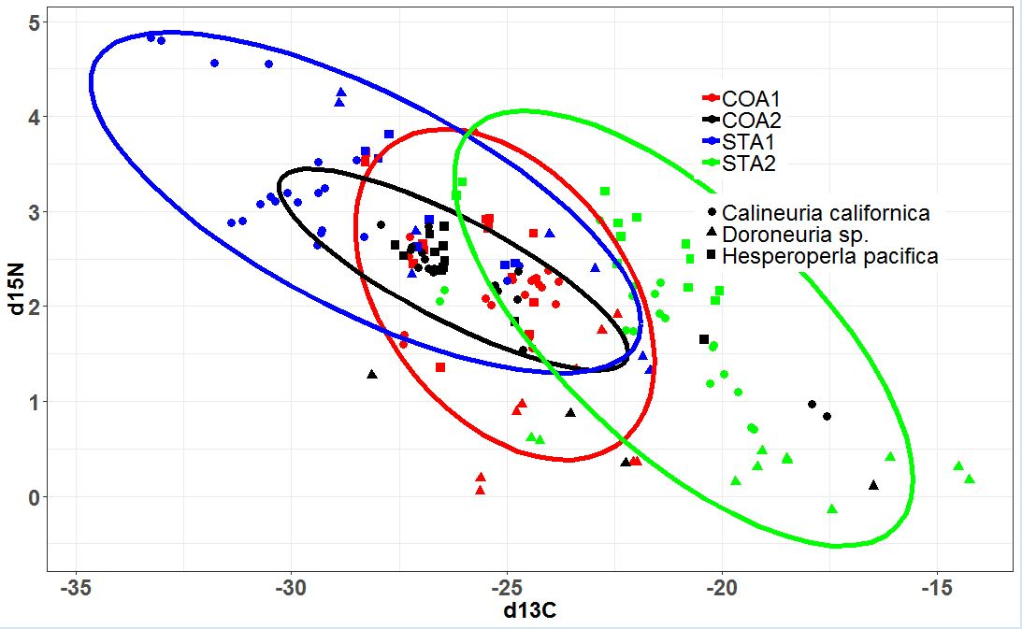
Figure 9. Distribution of d13C/d15N ratios by species of stonefly and location. Ratios sort better by location than they do by species. There was no species effect detected. Delta isotope values in PPT.
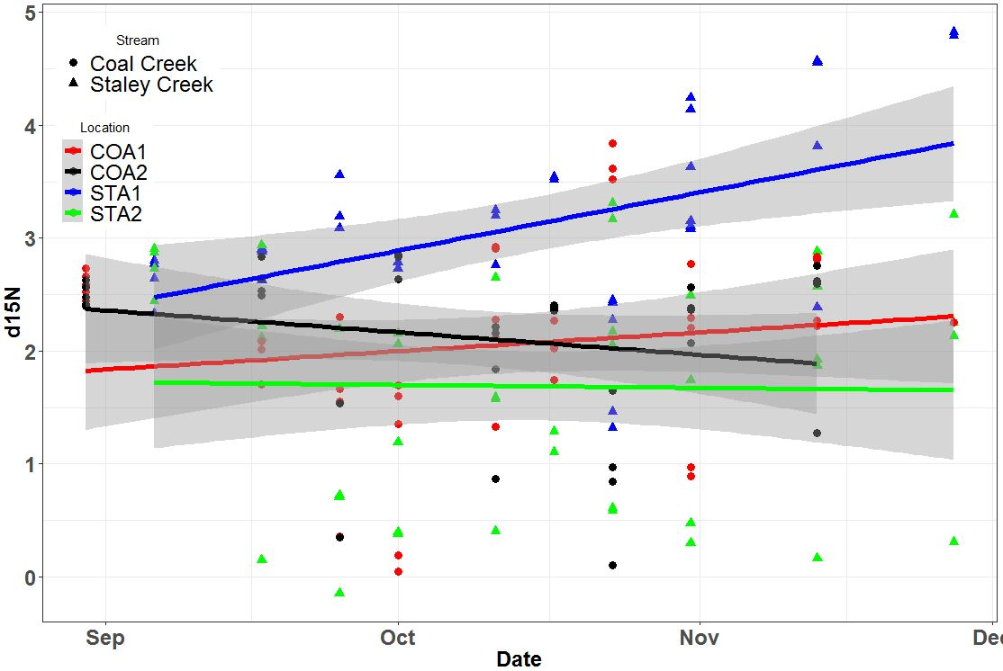
Figure 10. d15N of Perlid stonefly tissues over time after addition of Chinook salmon carcasses. Detrended time series generalized liniear model shows strong evidence for increased retention of 15N in LSFR reach. Error shading = 95% confidence, delta iso value=PPT
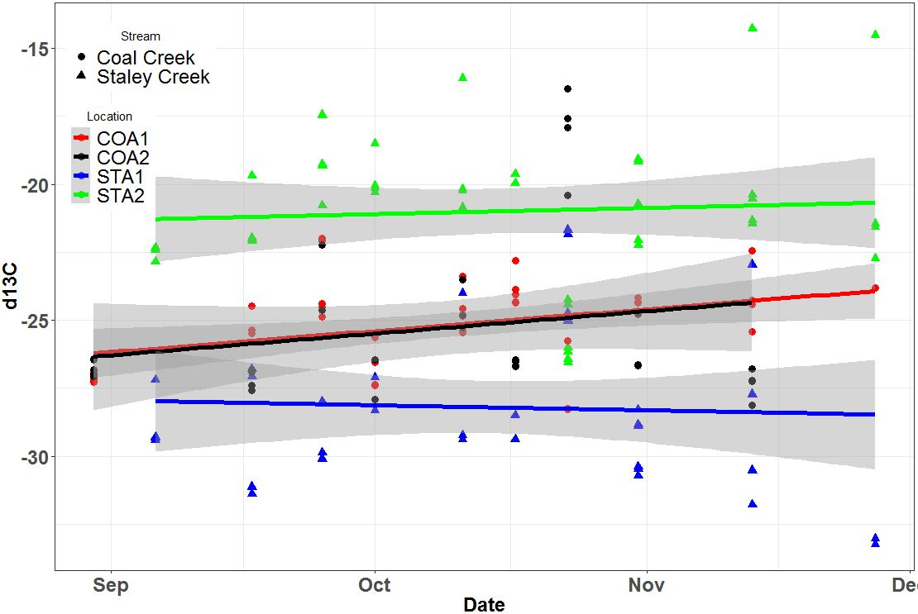
Figure 11. d13C of perlid stonefly tissues over time. Strong evidence for no time-series trend, and difference betwen the upper and lower Staley Creek reaches. Error shading = 95% confidence. Delta isotope values in PPT.

Coarse Particulate Organic Matter (CPOM) Monitoring

Purpose:
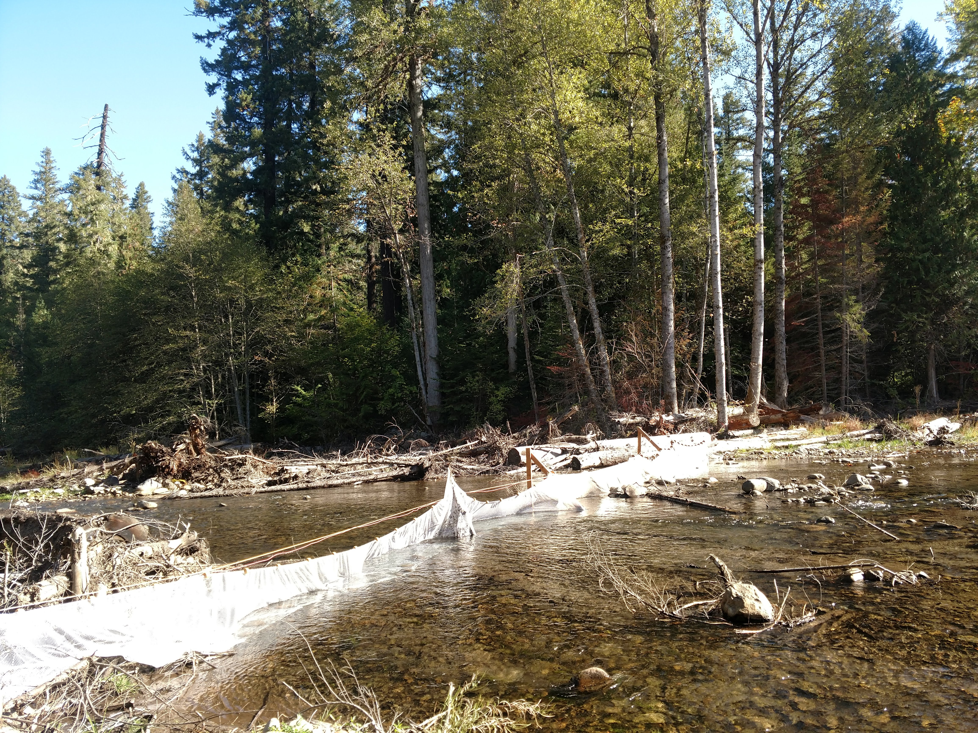
Restoration of stream channels may alter the foundation of the freshwater food web. These food webs begin with primary productivity, and include autochthonous productivity in the form of algal photosynthesis, and allochthonous productivity in the form of additions of organic matter from the riparian forest. In this project we examine restored and unrestored channels’ ability to retain coarse particulate organic matter derived from riparian productivity, i.e. leaves. These data may influence our understanding of restoration’s impact on the retention of leaves in the stream, and the potential benefits to the aquatic community.
Figure 12. block nets across Staley Creek restoration reach

Leaf Release Protocol:
Within the Coal Creek project area we randomly selected a 100 meter reach for before/after implementation releases of leaves. Leaves from introduced species of trees such as Ginko biloba were used to differentiate from naturally occurring leaves. These leaves were collected into 5000 leaf packs, soaked for 12 hours before being released to simulate natural buoyancy, and released simultaneously at spatially–balanced, random points across the upstream cross-section of the sample reach. At the downstream end of the experiment, leaves were collected over a 2 hour period in a fine mesh seine. Leaf retention was evaluated by calculating the proportion retained (# released (5000)-# collected in block-nets downstream. Within the Staley Creek project area, the above methods were used, with a 100 meter reach at the downstream end of the project biasedly selected and compared to a randomly selected upstream reference reach of the same gradient and valley width.
Duration:
The leaf release experiments will begin in the fall of 2018 and continue annually to describe the change in coarse particulate organic matter retention over time. All sites (N=3) received at least two leaf releases, with one release occurring at a low flow that approximates an average base-flow value and another release coinciding with a higher flow (Q1). Preferably, more releases will be done each season.
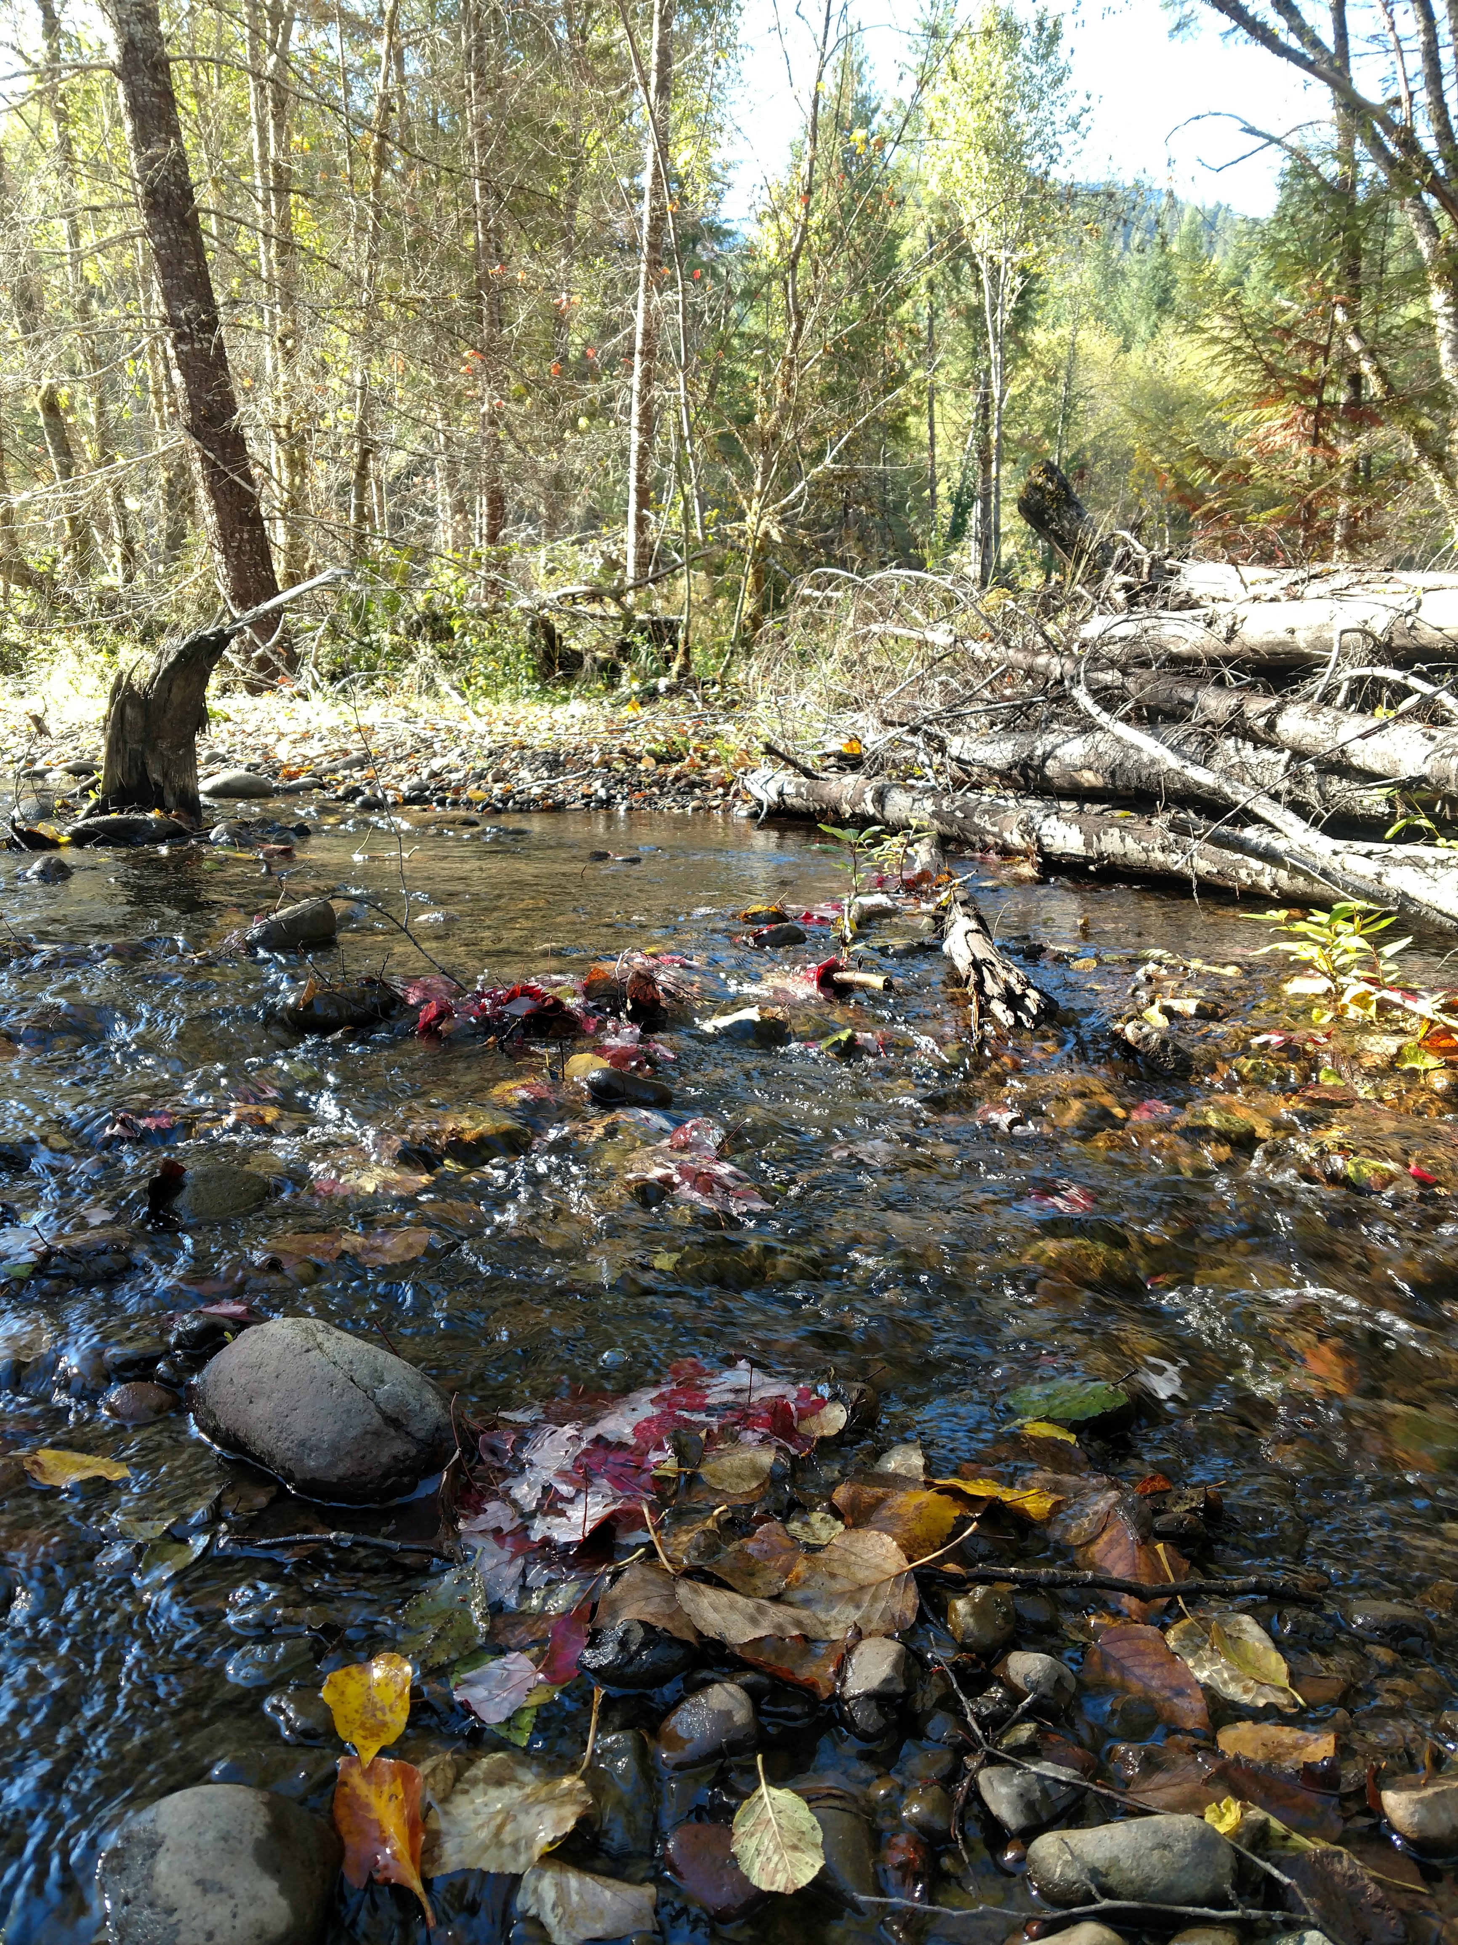
Figure 13. leaves on the margins
Analysis:
  - Coefficient of retention
  - Binomial probability of retention
    - By flow
    - By reach
    - By project hydrologic connectivity
    - Accounting for flow
    - Accounting for discharge
  - Qualitative assessment of retention within the reach

Results:
Increased retention of CPOM in the LSFR reach suggests that the retained allochthonus primary productivity within the reach is enhanced by the change in the hydrology. The channel has become rougher and lower energy. Increased retention of CPOM at the Staley Creek reference reach at higher flows is likely due to the simplicity of the channel. Most leaves retained in the Staley Creek Reference reach were retained in the margins of the stream as in the image to the right, whereas leaves were retained throughout the active channel within the restoration reach.
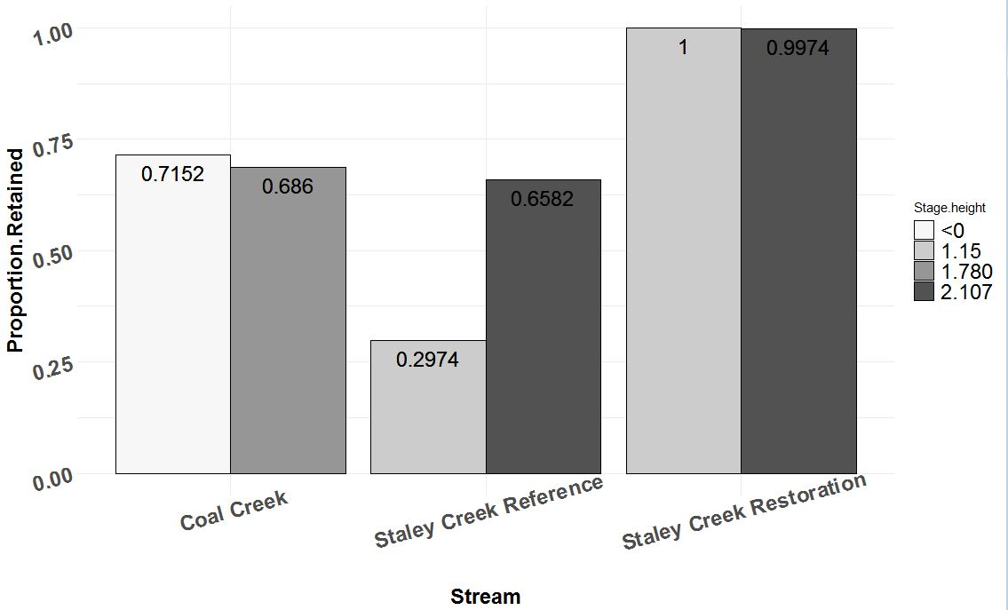
Figure 14. Proportions of leaves retained at base flow, and a heightened winter flow. N = 5000 per release per reach. No error estimated

Stream Temperature Monitoring

Purpose:
Staley Creek and Coal Creek thermal regimes have been altered due to anthropogenic influences, including timber harvest and channel cleaning. Stream temperature regimes define suitable habitats for aquatic organisms throughout their life stages and may limit the distribution and abundance of some cold water species, such as ESA listed bull trout and Chinook salmon. Monitoring temperature regimes at the reach level allows for investigations into longitudinal trends, thermal refugia, temperature heterogeneity, and potential effects of riparian cover and shade post restoration.
Protocol:
Stream temperature is recorded June-October in randomly selected patches within the restored area. Temperature monitoring is paired with the patch/grid surveys; randomly selected patches that are surveyed as “aquatic” receive a temperature logger. Patch surveys should be completed to determine aquatic patches prior to deploying temperature loggers.
Calibrate loggers in an ice bath followed by room temperature water to ensure accurate temperature measurements. Set temperature loggers to record temperature every half hour. Place loggers inside waterproof housing if necessary. For the 2018 season iButton temperature loggers were used. The iButtons were stored in a plastic whirl pack, inside a sealed metal housing. Attach cable for securing in stream and weight if needed.
Deploy temperature loggers in aquatic patches determined by the patch survey (Figure ###.). Navigate to the patch using a high-accuracy GPS unit, i.e. Juniper. Deploy logger in the deepest portion of the patch, measuring water depth at that location. Retrieve loggers in October, or until the possibility of high flows washing them out. Upon retrieval, measure water depth and record any important notes.
Temperature loggers above and below the restoration reach are also deployed June-October annually.
Preliminary Analysis:
Measure depth of water where loggers are placed during deployment and retrieval.
Deploy more loggers at randomly selected sites not associated with patch surveys?
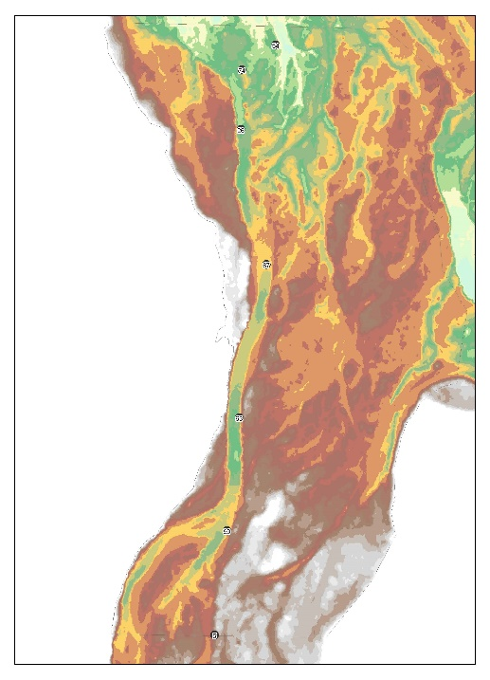
Is there a geographic relationship to temperature as we more downstream or out laterally on the floodplain?
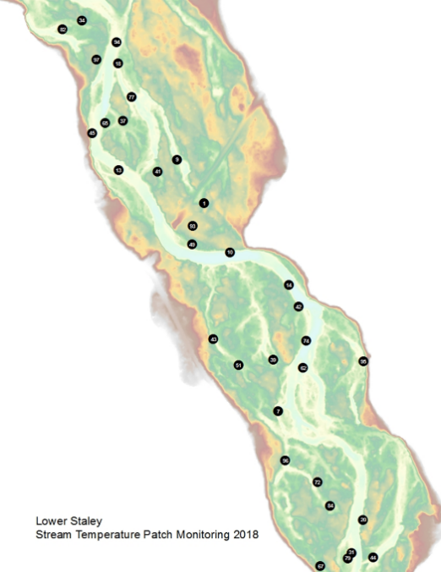
Figure 15. temperature logger locations in Staley Creek, 2018.

Figure 16. temperature logger locations in Staley Creek and Coal Creek, 2018
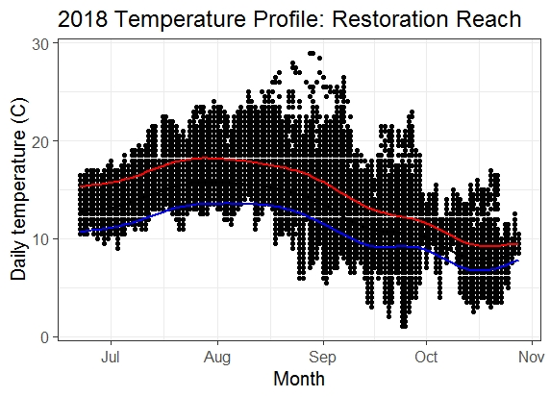
Figure 17. Daily temperature of all 33 monitoring sites in Staley Creek, 2018.

Flow Path Heterogeneity and Retention Rates Monitoring
Purpose: Stage 0 restoration techniques may increase residency time and nutrient retention by slowing the velocity of the stream and increasing channel roughness. Since nutrient retention rate is a function of the hydrologic residence time (Morrice et al. 1995), using a conservative tracer like salt to detect arrival time, mixing, and length of curve can provide a quantitative measure of residence time and be a proxy for nutrient retention. The salt slug injection method is simple and allows for measurements to be collected across all flow events to assess how storm events alter residence time and flow path connectivity.
Aside from collecting data pertaining to residence time and retention rate, the salt injection method also calculates a dependable discharge measurement in streams where a regular cross sectional discharge measurement would not be acceptable.
Protocol:
- Load map with valley cross sections and logger locations onto tablet for navigation to monitoring locations.
- Launch HOBO conductivity loggers at 10 second recording intervals and start loggers recording “On Date/Time” so they all start at the exact same time.
- Set up conductivity probes at the downstream end of restoration reach, generally outside of the original treatment area. Calibrate probes and begin logging data.
- Place conductivity loggers at the repeat monitoring sites located on the valley cross sections. Attach logger in a location where the wire probes are not touching substrate. Record last two numbers of logger serial number and its location.
- Place a single logger at the top of restoration reach to use as a control in the event that the injection site changes over time.
- Inject salt at the upstream end of restoration reach, or in side channel depending on results desired.
- Pull loggers and probes once the conductivity of the stream is no longer varying, as displayed by the probes.
- Using a flowmate, calculate flow at the downstream end of the restoration reach to verify injection data.
- Modified HOBO loggers do not record conductivity in micro Siemens, it is necessary to convert data from micro Seimens to “relative conductivity” to describe the electrode response (%RC=current signal/maximum observed signal during deployment*100) (Chapin et el. 2014).

Preliminary Results:
- Arrival time from a central mixing point
- Flow path heterogeneity/mixing when adding tracer to side channels
- Calculating discharge/percent flow in side channels to pair with temperature monitoring
- Determine if restoration reach is gaining or loosing
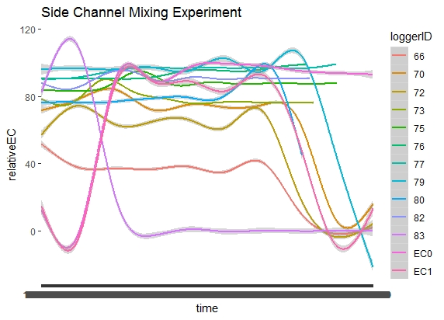
Figure 18. Conductivity readings from salt injection experiment to observe flow path/side channel mixing, observe the two pulses of salt detected.
Figure 18. Conductivity readings from salt injection experiment to observe flow path/side channel mixing, observe the two pulses of salt detected.

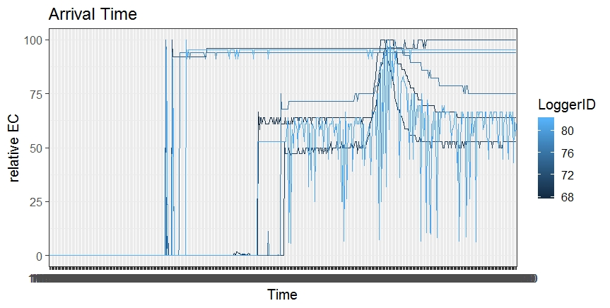
Figure 19. Conductivity readings from arrival time at cross sections experiment.
Figure 19. Conductivity readings from arrival time at cross sections experiment.

Bull Trout Occupancy and Habitat Usage Monitoring

Increasing the quality and quantity of habitat for listed fishes is one of the primary restoration goals of the LSFR project. In May of 2018, bull trout juveniles were documented using the project area, and an effort to track their movements and usage of the habitat followed. This effort included:
- Construction and maintenance of half-duplex PIT tag antennae at the upstream and downstream ends of the Staley project reach
- Minnow trapping and snorkel-capture of bull trout juveniles in Coal and Staley Creeks
- Adult Bull trout spawning ground surveys in Coal and Staley Creeks
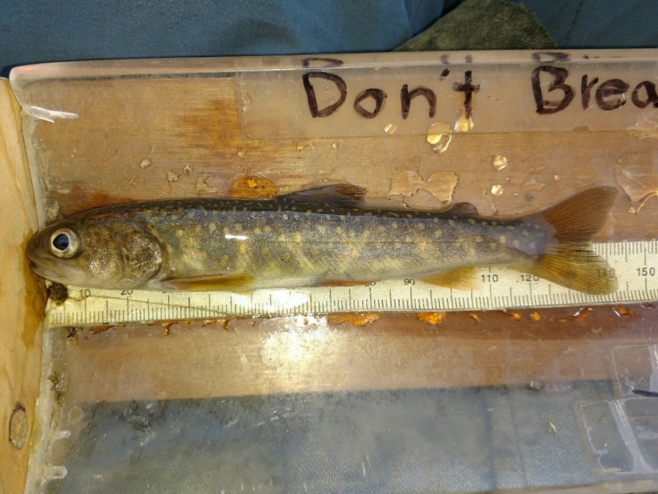
- Environmental DNA (eDNA) surveys of Coal, Staley and nearby tributaries of the Upper Middle Fork Watershed
Figure 20. Bull trout captured in Staley Creek, 2018.
Figure 20. Bull trout captured in Staley Creek, 2018.
Minnow trapping protocol consisted of overnight sets of typically forty traps baited with salmon roe. The morning of the following day, fish were collected, diversity of fish was recorded, and all bull trout received 23mm half-duplex PIT tags, length measurements, and pelvic-fin clip marks/DNA tissue samples.
Snorkeling was done at night, with variable numbers of technicians, and qualitative species data were collected. Bull trout were captured by hand net, when possible.
Bull trout were tagged when captured in multiple efforts in Coal and Staley Creeks, and because the number of fish tagged was very low (n=6), they are assumed to not be abundant in these streams. However, more extensive sampling is needed to determine relative population size. Bull trout ranged in size from 119-150mm and likely represent the 1+ age class.
All five fish captured in Staley Creek were detected on one or more antenna. Figure Q shows time and place of the detections.
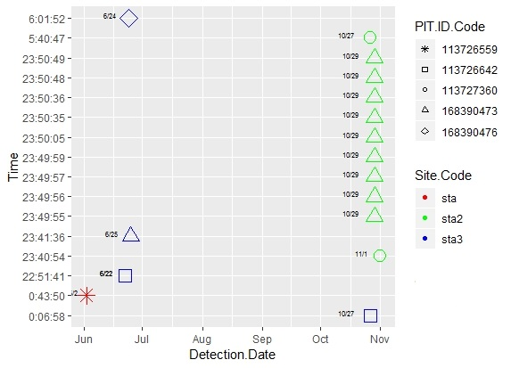
Figure 21. Detection date, and PIT tag ID codes on three antennae. STA is located at the bridge where the 2134 road crosses the Middle Fork Willamette, STA 2 is located at the downstream end of the LSFR project area, and STA3 is located upstream of LSFR.

Spawning ground surveys followed the existing protocol for bull trout and Chinook salmon surveys in the upper Middle Fork Willamette that are implemented jointly by Oregon Department of Fish and Wildlife and the Middle Fork Ranger District Fisheries staff. Beginning at the confluences of Coal and Staley Creeks, technicians walked two miles of stream, every two weeks between September 5th, 2018 and October 23rd, 2018. These reaches included the LSFR project reach, and the proposed Coal Creek site. No adult fish, or evidence of spawning activity was recorded on these streams during this time.
eDNA surveys were conducted in July and August 2018, across the upper Middle Fork Willamette watershed. These surveys included Coal and Staley Creeks and resulted in positive detections of bull trout downstream of both the Coal and Staley project reaches, but no upstream replicates resulted in positive detections. Nearby Echo and Tumblebug Creeks also had positive detections at lower sample sites.

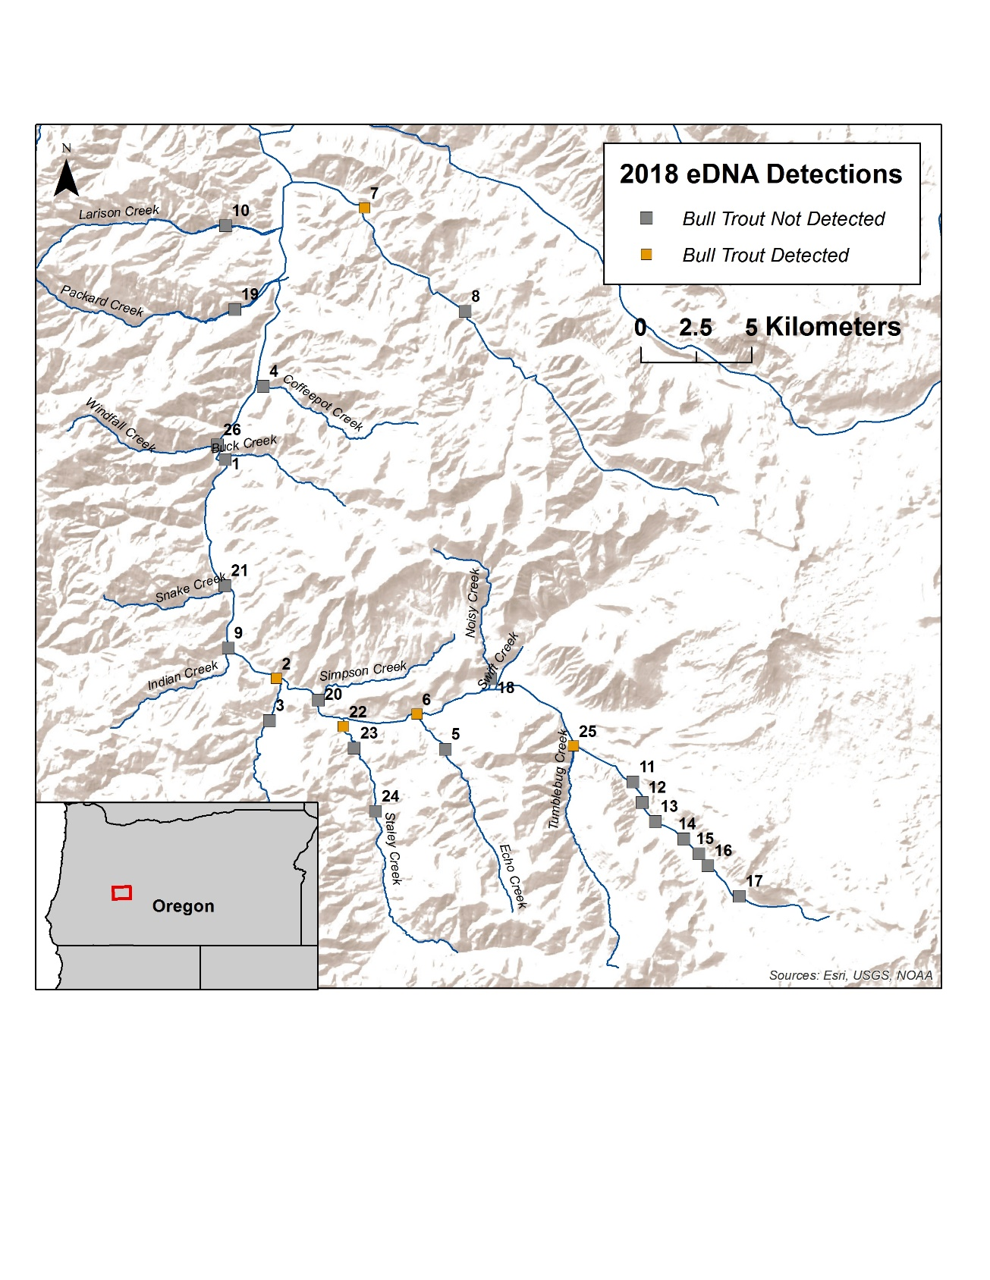
Figure 22. Upper Middle Fork Willamette River, July/August 2018 eDNA detections for Bull trout.

Recommendations:

Nutrient and CPOM Monitoring
Despite the low number of streams monitored, we observed a conciliant pattern among our nutrient retention and CPOM experiments. We used the addition of carcasses and their traceable 15N signature to see how nutrients flowed in the different reaches, and found that the newly restored Staley Creek reach had macroinvertebrates that were actively taking up and storing those nutrients. These findings are further substantiated by the dissolved nitrogen signatures, that show less NO₃ leaving the restored reach in stream water. Coal Creek, the unrestored reference stream, did not exhibit those patterns. Marine derived carbon (13C) became less important to the diets of macroinvertebrates in the restored stream, likely because of the coarser channel and the increased retention of CPOM, large wood, and influx of organic matter from the soil throughout restoration. These findings are very preliminary, and while they follow logically, need more data from a variety of restored and unrestored streams before we can draw conclusions about the nature of hydrology’s relationship with nutrient storage. However, they are a strong indication of ecosystem function following restoration. We recommend continued monitoring on Staley Creek, after the 2019 implementation on Coal Creek, and for these metrics to be tried on non-process-based restoration projects like large wood additions, off channel pool construction, replanting, etc. Stage 0 is an expensive and intensive technique, and we want to know: Are we restoring ecosystem function? Do other restoration techniques have the same impacts on nutrient cycling?

Stream Temperature Monitoring
We feel that the high number of temperature loggers is essential to capture heterogeneity of temperature throughout the restoration reach. While decrease in depth, and increased water surface area has lead to some thermal loading in the reach, we so far have observed the retention of some cold-water refugia. With this ongoing robust sample of temperature within the project reaches, we hope to begin collecting covariates that may influence temperature at that location. More years of temperature data are needed.

Flow Path Heterogeneity Monitoring
The use of inexpensive conductivity loggers is an exciting new technique for modeling heterogeneity in complex environments. In our first year we have explored the plausibility of using these loggers throughout the floodplain to look at local discharges, flow paths, and retention time in various channels. We look forward to honing our questions and improving on this technique in the 2019 monitoring season.

Bull Trout Occupancy and Habitat Usage Monitoring
Bull Trout had not been observed using Staley and Coal Creeks since before the local extirpation in the Upper Middle Fork Willamette, until May of 2018. We will maintain PIT tag arrays on Staley Creek, and continue to monitor their usage of the Lower Staley and Coal Creek Floodplain Restoration Project areas. We hope to construct arrays on Coal Creek, PIT tag more juvenile Bull Trout, and work towards describing the changes in habitat use in these two watersheds over time.
The following is a schedule to the field collection component of the analysis.
Table 1. Schedule of collection metrics and methods
Metric | Method | Timeline
Stream temperature | Temperature loggers in wet patches | May-October, annually/Year round?
Nutrient retention | Water samples analyzed for NO3, NH4, total dissolved | Year round, Sept-Dec NH4 + total dissolved, annually
Nutrient retention | Macroinvertebrate samples analyzed for d13C and d15N | September-December, annually
Habitat heterogeneity | Patch surveys / Photogrammetry | Base flow(June), annually/ seasonally
Presence of sensitive species/bull trout | Minnow trapping, electrofishing, spawning surveys, snorkeling/deploying PIT tags/antennas | Year round/As needed
Flow path heterogeneity | Conductivity loggers and salt dilution discharge measurements | Year round, capturing multiple flow events

Citations/Suggested Reading:
- Baxter, Colden V., Fausch, Kurt D., and W. Carl Saunders. Tangled webs: reciprocal flows of invertebrate prey link streams and riparian zones. Freshwater Biology. 2005. 50, 201-220.
- Brian Cluer and Colin R. Thorne. 2014. A Stream Evolution Model: Integrating Habitat and Ecosystem Benefits. River Research and Applications. 30, Issue 2, 135-154.
- Carim, Kellie J., McKelvey, Kevin S., Young, Michael K., Wilcox, Taylor M., and Michael K. Schwartz. A Protocol for Collecting Environmental DNA Samples From Streams.USDA Forest Service Gen. Tech. Rep. RMRS-GTR-355. 2016. https://www.fs.fed.us/rm/pubs/rmrs_gtr355.pdf
- Helton, Ashley M.; Poole, Geoffrey C.; Meyer, Judy L.; Wollheim, Wilfred M.; Peterson, Bruce J.; Mulholland, Patrick J.; Bernhardt, Emily S.; Stanford, Jack A.; Arango, Clay; Ashkenas, Linda R.; Cooper, Lee W.; Dodds, Walter K.; Gregory, Stanley V.; Hall, Robert O., Jr.; Hamilton, Stephen K.; Johnson, Sherri L.; McDowell, William H.; Potter, Jody D.; Tank, Jennifer L.; Thomas, Suzanne M.; Valett, H. Maurice; Webster, Jackson R.; Zeglin, Lydia. 2011. Thinking outside the channel: modeling nitrogen cycling in networked river ecosystems. Frontiers in Ecology and the Environment. 9(4): 229-238
- Marcarelli, Amy M., Baxter, Colden V., and Mark S. Wipfli. Nutrient additions to mitigate for loss of Pacific salmon: consequences for stream biofilm and nutrient dynamics. 2014. Ecosphere 5(6):69
- Lamberti, Gary. A., Gregory, Stan. V., Ashkenas, Linda R., Wildman, Randall C., and Alan D. Steinman. Influence of channel geomorphology on retention of dissolved and particulate matter in a cascade mountain stream. USDA Forest Service Gen. Tech. Rep. PSW-110. 1989.
- Timo Muotka and Pekka Laasonen. Ecosystem recovery in restored headwater streams: the role of enhanced leaf retention. Journal of Applied Ecology. 2002. Issue 39, 145-156.

